Retail Analysis with Walmart Data

Analysis Task

Loaded the Dataset in the working directory.
Performed basic analysis task on the dataset.

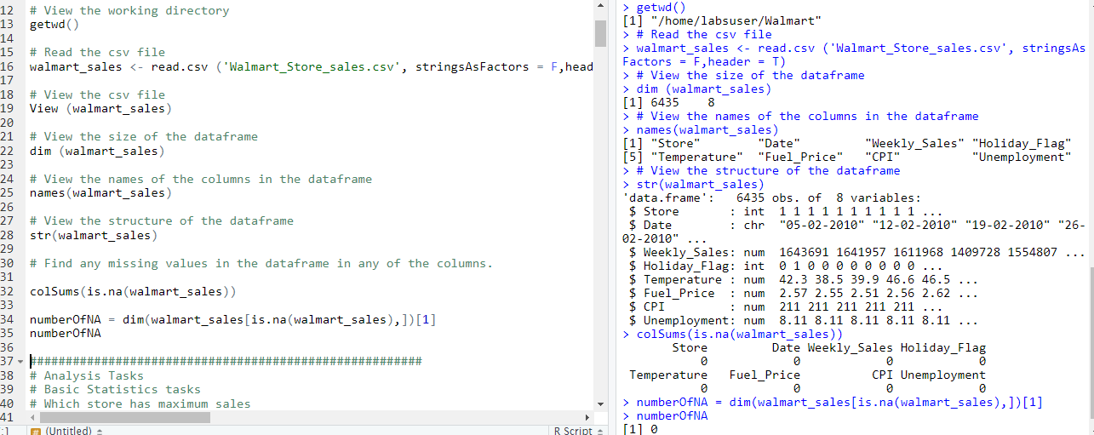

Insight:
Walmart sales dataset has 6435 records and 8 columns. No Null values in any of the columns/ records.

Basic Statistics Task

Question 1:
Which store has maximum sales

To find the store which has maximum sales. Performed a sort on the dataset using order () function, on weekly basis in descending order and picked the first record.

R code:
walmart_sales[order(-walmart_sales$Weekly_Sales),][1,c('Store','Weekly_Sales')]

Screen Shot:
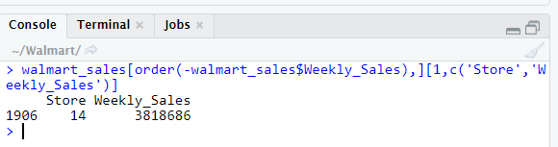

Question 2:
Which store has maximum standard deviation i.e., the sales vary a lot. Also, find out the coefficient of mean to standard deviation

Step 1:
Calculated Mean of weekly sales in each store by using aggregate () function.

R Code:
# View the Mean of Weekly Sales in each store
grouped_store_mean<- aggregate(walmart_sales$Weekly_Sales, by = list(walmart_sales$Store), FUN = mean )
names(grouped_store_mean)<- c('Store_ID','Mean')
grouped_store_mean

Screen Shot:
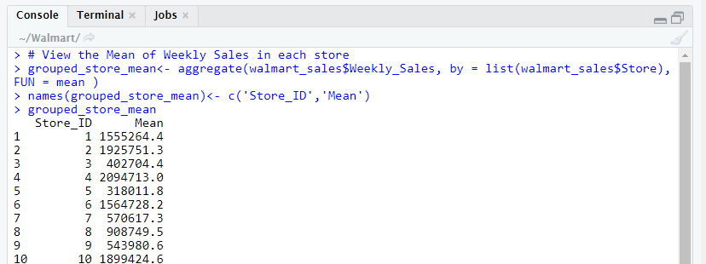

Visualize the Store wise Mean weekly sales using ggplot () function
R Code:
ggplot(grouped_store_mean, aes(x=factor(Store_ID), y= Mean))+
geom_bar(stat="identity", width=0.7,fill ='lightblue')+
theme_minimal()

Screen Shot:

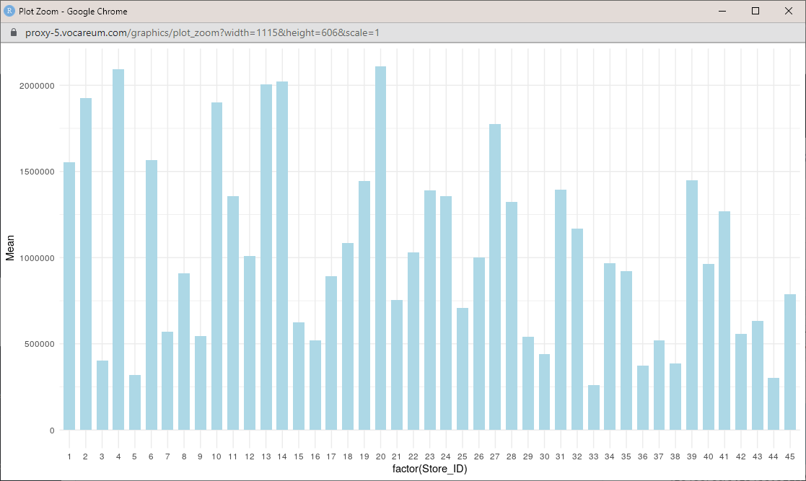

Step 2:
Calculated Standard Deviation of weekly sales in each store by using aggregate () function.

R Code:
# View the Standard Deviation of Weekly Sales in each store
grouped_store_sd<- aggregate(walmart_sales$Weekly_Sales, by = list(walmart_sales$Store), FUN = sd )
names(grouped_store_sd)<- c('Store_ID','Standard_Dev')
grouped_store_sd

Screen Shot:
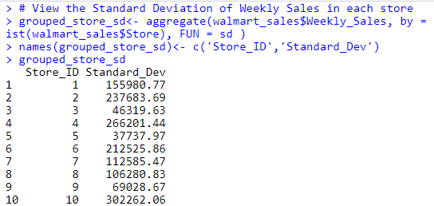
Visualize Store wise Standard deviation using ggplot () function.
R Code:
ggplot(grouped_store_sd, aes(x=factor(Store_ID), y= Standard_Dev))+
geom_bar(stat="identity", width=0.7,fill ='green')+
theme_minimal()

Screen Shot:
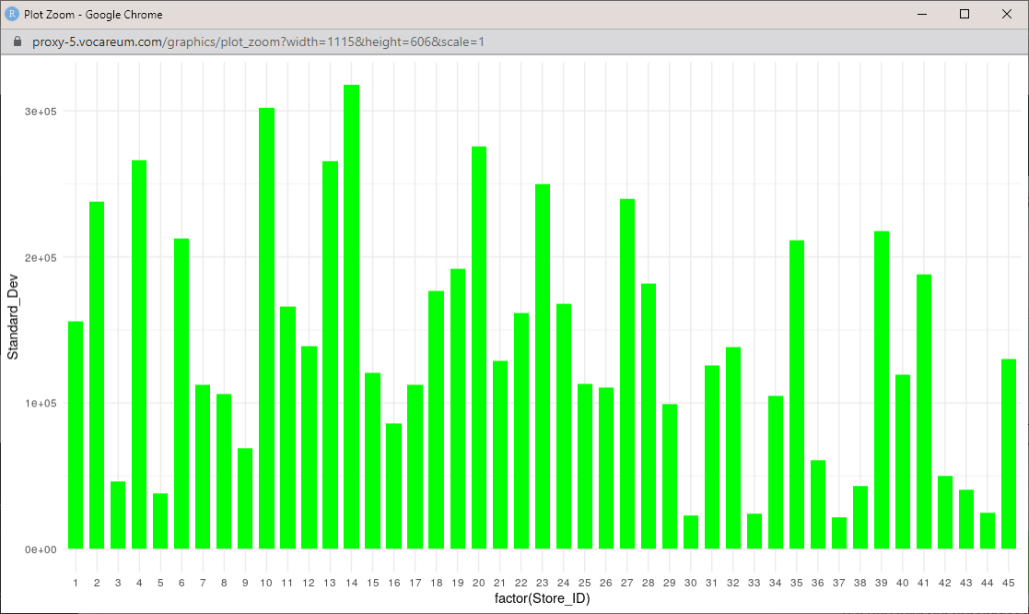

Step 3:
Created a data frame with Mean and Standard deviation for each store.

R Code:
# Create a Dataframe with Mean and Standard deviation of Weekly sales in each store
walmart_stat <- merge(grouped_store_mean, grouped_store_sd, by ='Store_ID', all.x = T)
View (walmart_stat)

Screen Shot:
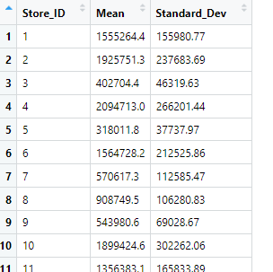

Step 4:
Calculated coefficient of Mean to Standard deviation for each store and stored in the dataframe.

R Code:
# Calculate the Coeffecient of Mean to the Standard deviation and append to the dataframe walmart_stat
walmart_stat$coeff <- (walmart_stat$Standard_Dev / walmart_stat$Mean) * 100
View (walmart_stat)

Screen Shot:
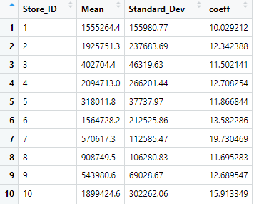

Step 5:
To figure out the store ID with maximum standard deviation performed a sort by using order () function on standard deviation column in descending order and picked the first record.

R Code:
# View the store ID with maximum standard deviation.
walmart_stat[order(-walmart_stat$Standard_Dev),][1,]

Screen Shot:
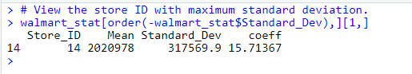

Question 3:
Which store/s has good quarterly growth rate in Q3’2012

Step 1:
View the structure of the Date field using str () function.
Convert the Date field into Date type using as.Date () function.

R Code:
# View the structure of the Date field
str(walmart_sales$Date)

# Convert char Date into Date format
walmart_sales$Date <- as.Date(walmart_sales$Date, format = "%d-%m-%Y")

Screen Shot:
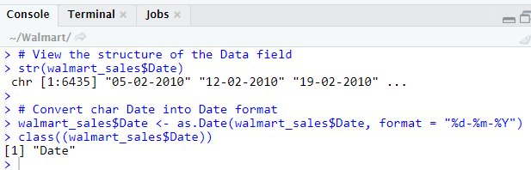

Step 2:
Split the Year and Month using format () function and stored as a separate column in the data frame.

R Code:
# Split Year from the date
walmart_sales$Year <- format(walmart_sales$Date, format = "%Y")

# Split Month from the date
walmart_sales$Month <- format(walmart_sales$Date, format = "%b")

Step 3:
Calculate Quarters field using Quarters () function on the date field. Store the values as a separate field in the data frame.

R Code:
# Calculate Quaters
walmart_sales$Quater <- quarters(walmart_sales$Date)
View (walmart_sales)

Screen Shot:
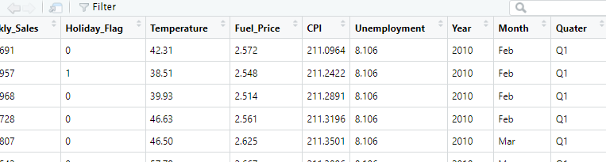

Step 4:
Filter the records in 2012 Q2 and Q3 and stored the filtered records in a separate data frame.

R Code:
# Filter the records in 2012 - Q2 and Q3

walmart_sales_2012 <- walmart_sales[walmart_sales$Year == '2012' & walmart_sales$Quater %in% c('Q2','Q3'),]
View (walmart_sales_2012)

Screen Shot:

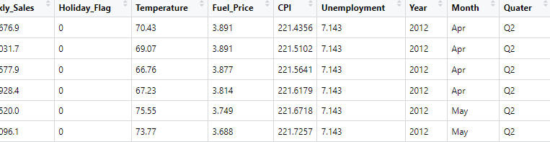

Step 5:
Group the weekly sales store wise using the aggregate () function by Quarters field.

R Code:
# Aggregate store level weekly sales

grouped_store_sum<- aggregate(walmart_sales_2012$Weekly_Sales, by = list(walmart_sales_2012$Quater,walmart_sales_2012$Store), FUN = sum )
names(grouped_store_sum)<- c('Store_ID','Quater','Total_Sales')
grouped_store_sum

Screen Shot:
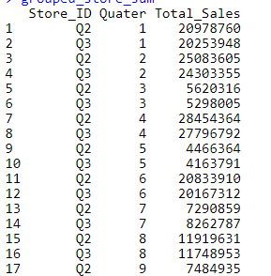

Insight:
Got the Quarterly (Q2 & Q3 2012) total weekly sales for each store.

Step 6:
Created a subset with Store ID and Q2 sales
Created another subset with Store ID and Q3 sales
Merged the data by Store ID to have Q2 and Q3 sales data for each store ID
R Code:
# Created a subset with Store ID and Q2 sales
Quater_Q2 <- subset(grouped_store_sum,Quater=='Q2',select=c(Store_ID,Total_Sales))
names(Quater_Q2) <- c('Store_ID','Q2_Sales')

# Created a subset with Store ID and Q3 sales
Quater_Q3 <- subset(grouped_store_sum,Quater=='Q3',select=c(Store_ID,Total_Sales))
names(Quater_Q3) <- c('Store_ID','Q3_Sales')

# Merged the data by Store ID to have Q2 and Q3 sales data for each store ID
Quater_Q2Q3 <- merge(Quater_Q2, Quater_Q3, by ='Store_ID', all.x = T)
View(Quater_Q2Q3)

Screen Shot:
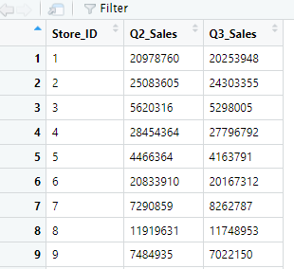

Step 7:
Calculate the Quarterly sales for each store - (Q3-Q2 / Q2)*100
R Code:
Quater_Q2Q3$Growth_rate <- (((Quater_Q2Q3$Q3_Sales - Quater_Q2Q3$Q2_Sales)/Quater_Q2Q3$Q2_Sales)*100)
View(Quater_Q2Q3)

Screen Shot:
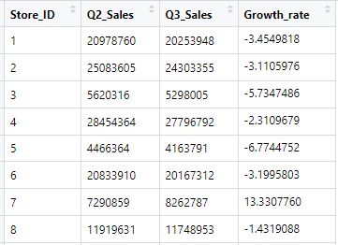

Step 8:
Ordered the subset data set by Growth rate using order () function in descending order and picked the First record

R Code:
Quater_Q2Q3[order(-Quater_Q2Q3$Growth_rate),][1,]

Screen Shot:
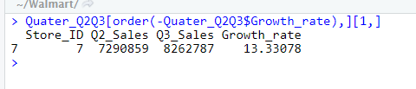

Insights:
Store ID 7 has good quarterly growth rate.

Question 4:
Some holidays have a negative impact on sales. Find out holidays which have higher sales than the mean sales in non-holiday season for all stores together.

Step 1:
Create a new column ‘Holiday Type’ in the data frame with the dates given for each holiday type.

Holiday Events
Super Bowl: 12-Feb-10, 11-Feb-11, 10-Feb-12, 8-Feb-13
Labour Day: 10-Sep-10, 9-Sep-11, 7-Sep-12, 6-Sep-13
Thanksgiving: 26-Nov-10, 25-Nov-11, 23-Nov-12, 29-Nov-13
Christmas: 31-Dec-10, 30-Dec-11, 28-Dec-12, 27-Dec-13

R Code:
for (i in 1:nrow(walmart_sales)){
if (walmart_sales$Date[i] %in% c(as.Date('2010-02-12'), as.Date('2011-02-11'), as.Date('2012-02-10'), as.Date('2013-02-08'))){
walmart_sales$Holiday_Type[i] <- 'Super Bowl'
}else if(walmart_sales$Date[i] %in% c(as.Date('2010-09-10'), as.Date('2011-09-09'), as.Date('2012-09-07'), as.Date('2013-09-06'))){
walmart_sales$Holiday_Type[i] <- 'Labour Day'
}else if(walmart_sales$Date[i] %in% c(as.Date('2010-11-26'), as.Date('2011-11-25'), as.Date('2012-11-23'), as.Date('2013-11-29'))){
walmart_sales$Holiday_Type[i] <- 'Thanksgiving'
}else if(walmart_sales$Date[i] %in% c(as.Date('2010-12-31'), as.Date('2011-12-30'), as.Date('2012-12-28'), as.Date('2013-12-27'))){
walmart_sales$Holiday_Type[i] <- 'Christmas'
}else{
walmart_sales$Holiday_Type[i] <- 'Not Holiday'
}
}
View(walmart_sales)

Screen Shot:
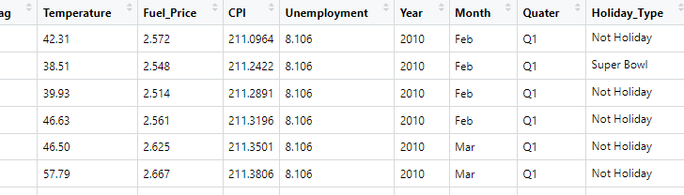

Step 2:
Visualize the Total weekly sales based on each holiday type using boxplot to find the Mean and Outliers.

R Code:
boxplot(walmart_sales[, 3] ~ walmart_sales[, 12],
main = "Weekly Sales based on Holiday Type",
xlab ="Holiday Type",
ylab ="Total Weekly Sales",
col="lightblue")

Screen Shot:
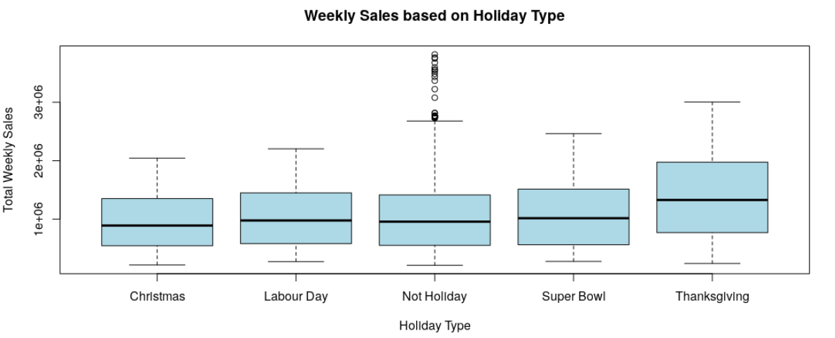
Insight:
Total Weekly sales during Thanksgiving holiday is more compared to the other Holiday Type and Non holiday days. There are outliers in the non-Holiday data.

Step 3:
To find the total weekly sales for each holiday type, filtered the records with holiday_flag as 1 and grouped the weekly sales by holiday type – Super Bowl, Labor Day, Thanksgiving, Christmas using aggregate () function.

R Code:
# Filter the sales records with holiday flag as 1
holiday <- walmart_sales[walmart_sales$Holiday_Flag == '1',]

# Group the total weekly sales by each holiday type
grouped_holiday_type<- aggregate(holiday$Weekly_Sales, by = list(holiday$Holiday_Type), FUN = sum )

# Name the Columns
names(grouped_holiday_type)<- c('Holiday_Type','Total_Sales')

# View the Total sales based on Holiday Type
grouped_holiday_type

Screen Shot:
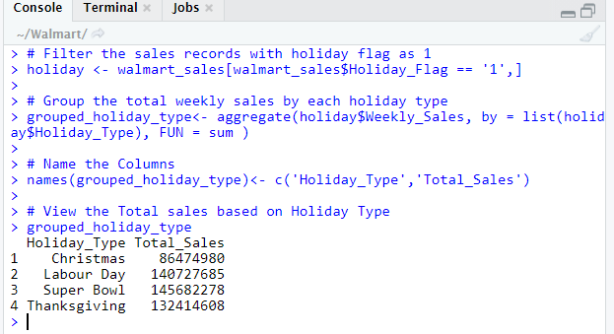

Step 4:
To find the total weekly sales for each holiday type, filtered the records with holiday flag as 0.
Perform sum () function to find the total sales and mean () function to find the average sales during non-holidays.

R Code:
# Filter the sales records with holiday flag as 0
non_holiday <- walmart_sales[walmart_sales$Holiday_Flag == '0',]
View (non_holiday)

# Total weekly sales during Non Holiday season
non_holiday_sum <- sum(non_holiday$Weekly_Sales)
non_holiday_sum

# Average Total sales during Non Holiday season
non_holiday_mean <- mean(non_holiday$Weekly_Sales)
non_holiday_mean

Screen Shot:
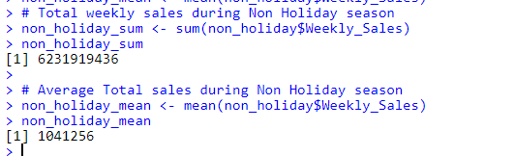

Step 5:
Compare the mean total weekly sales with the total weekly sales of each holiday type.

R Code:
# View the Holidays which have higher sales than the mean sales
# in non-holiday season for all stores together

for (i in 1:nrow(grouped_holiday_type)){
if (grouped_holiday_type$Total_Sales[i] > non_holiday_mean){
print(grouped_holiday_type$Holiday_Type[i])
}
}

Screen Shot:
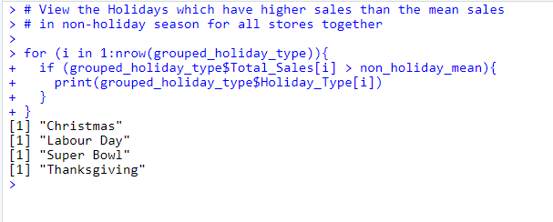

Insight:
All the holiday types have total sales more than mean total sales of non-holiday type.

Step 6:
Using ggplot () function to visualize the weekly total sales for each holiday type and geom hline () function to plot a horizontal line on the Mean of weekly total sales for non-holidays.

R Code:
# Visualize Total weekly sales for each holiday type
# and Mean of Total weekly sales of non holidays.

h <- ggplot(grouped_holiday_type, aes(x=factor(Holiday_Type),y = Total_Sales))+
geom_bar(stat="sum", width=0.7, fill="lightblue" )+
theme_minimal()

h + geom_hline(aes(yintercept = non_holiday_mean),
color="red", linetype="solid", size=3)

Screen Shot:
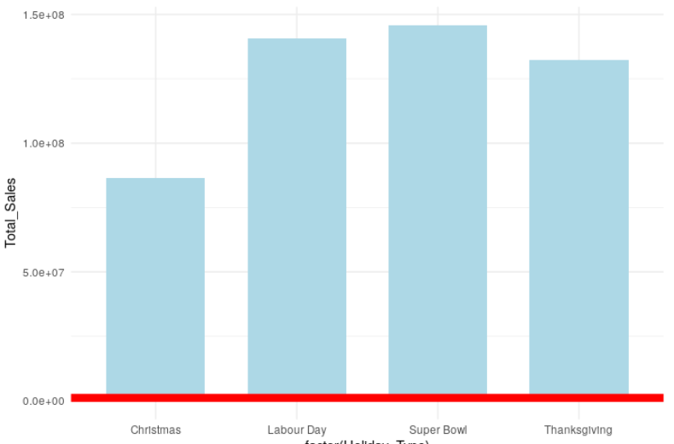
Insight:
All the holiday types have total sales more than mean total sales of non-holiday type.

Question 5:
Provide a monthly and semester view of sales in units and give insights

Step 1:
Calculate the Total weekly sales month wise by grouping the records month wise using aggregate () function.

R Code:
# View Monthwise Total sales
grouped_month_wise<- aggregate(walmart_sales$Weekly_Sales, by = list(walmart_sales$Month), FUN = sum )
names(grouped_month_wise)<- c('Month','Total_Sales')
grouped_month_wise

Screen Shot:
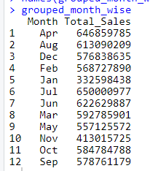

Step 2:
Visualize the Month wise Weekly Total sales for all the stores by using barplot () function.

R Code:
# Barplot MonthWise Total sales

barplot(height = grouped_month_wise$Total_Sales,
names = grouped_month_wise$Month,
main="Month Wise Sales",
xlab="Month",
ylab="Total Sales"
)

Screen Shot:
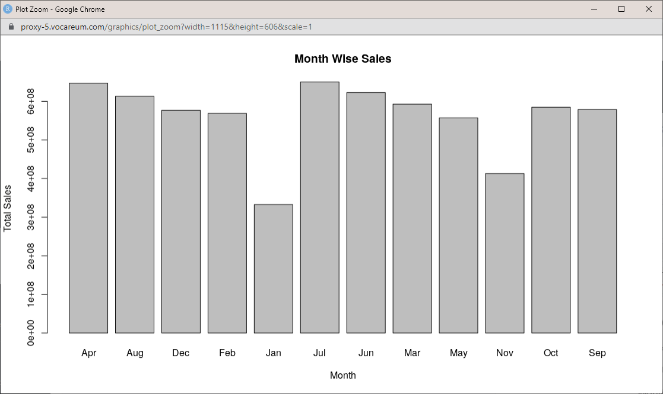
Insight:
April and July months have the maximum sales. Jan and Nov has low sales compared to the other months.

Step 3:
To view the total sales semester wise, create a column in the data frame to indicate the semester flag as H1 and H2

R Code:
# Create a column for Semester
for (i in 1:nrow(walmart_sales)){
if(walmart_sales$Quater[i] %in% c('Q1','Q2')){
walmart_sales$Semester[i] <- 'H1'
}else{
walmart_sales$Semester[i] <- 'H2'
}
}
View(walmart_sales)

Screen Shot:
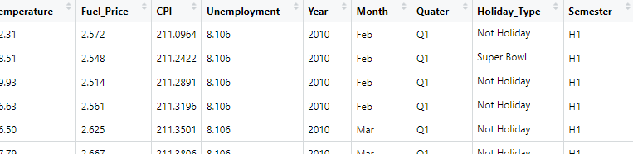

Step 4:
Calculate the Half-yearly wise total sales using aggregate () function.

R Code:
# View Half Yearly wise Total sales
grouped_halfyearly_wise<- aggregate(walmart_sales$Weekly_Sales, by = list(walmart_sales$Semester), FUN = sum )
names(grouped_halfyearly_wise)<- c('Half_Yearly','Total_Sales')
grouped_halfyearly_wise

Screen Shot:
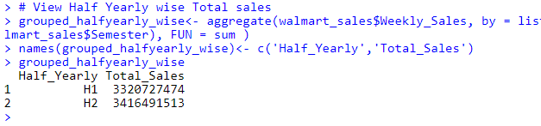

Step
Visualize the Semester wise total sales using the barplot () function.

R Code:
# Barplot HalfYearly wise Total sales

barplot(height = grouped_halfyearly_wise$Total_Sales,
names = grouped_halfyearly_wise$Half_Yearly,
main="HalfYearly Wise Sales",
xlab="Semester",
ylab="Total Sales"
)

Screen Shot:
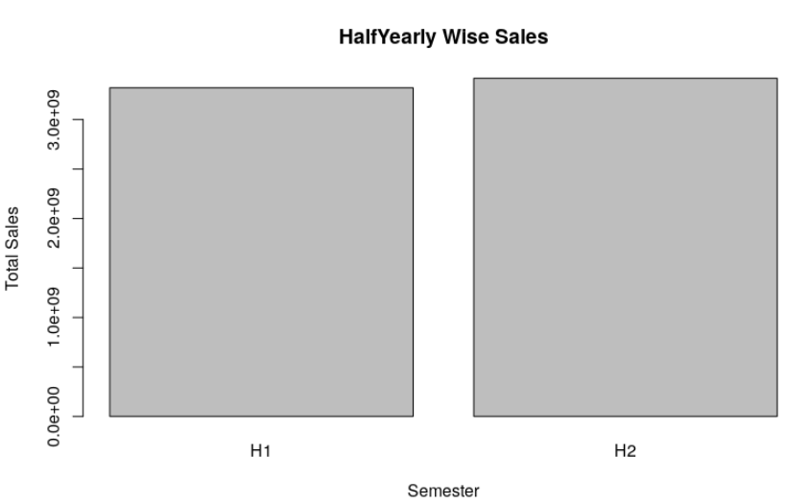
Insights:
H2 have a slightly more total sale than H1.

Statistical Model
Question 1:

For Store 1 – Build prediction models to forecast demand

Model 1:
Linear Regression – Utilize variables like date and restructure dates as 1 for 5 Feb 2010 (starting from the earliest date in order). Hypothesize if CPI, unemployment, and fuel price have any impact on sales.

Step 1:
View the pairwise relationship between the variables

R Code:
par(mfrow=c(3,3))
for(i in 4:8){
plot(walmart_sales[,i],
walmart_sales$Weekly_Sales,
main=names(walmart_sales[i]),
ylab=names(walmart_sales$Weekly_Sales),
xlab="", col='indianred4')
}
Screen Shot:
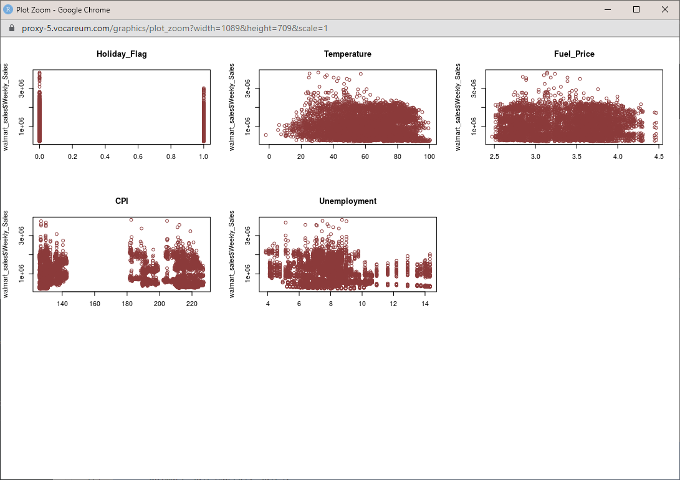

Step 2:
Filter unique dates from the dataset using unique () function

R Code:
# Filter unique dates from the dataset using unique () function
Date <- unique(walmart_sales$Date)
Date

Screen Shot:
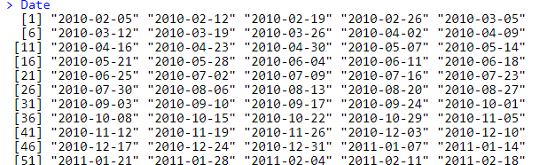
Step 3:
Create a sequence number from 1 to length of the unique dates

R Code:
Date_index <- seq(1:length((Date)))
Date_index

Screen Shot:
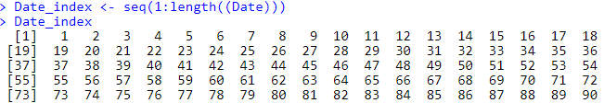

Step 4:
Created a data frame with unique dates and index created

R Code:
date_frame <- data.frame(Date,Date_index)
View (date_frame)
Screen Shot:
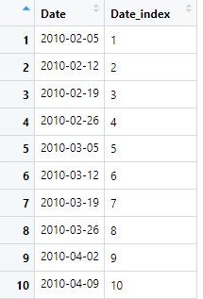
Insight:
First date will be having 1 as unique index number. Each date will have a unique index number.

Step 5:
Merge the index data frame with original data frame and store in a new data frame

R Code:
walmart_sales_new <- merge(walmart_sales, date_frame, by ='Date', all.x = T)
View (walmart_sales_new)

Screen Shot:
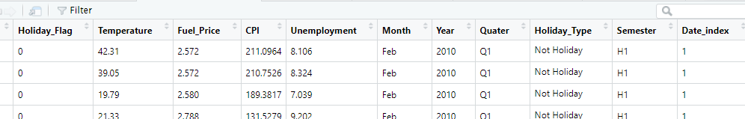

Step 6:
View the column names of the new data frame created with the date index

R Code:
names(walmart_sales_new)

Screen Shot:
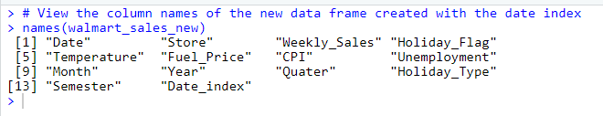

Outlier Treatment:
Step 1:
View the boxplot for all the individual variables to figure out the outliers.

R Code:
boxplot(walmart_sales_new$Temperature, main='Temperature')
boxplot.stats(walmart_sales_new$Temperature)$out

Screen Shot:
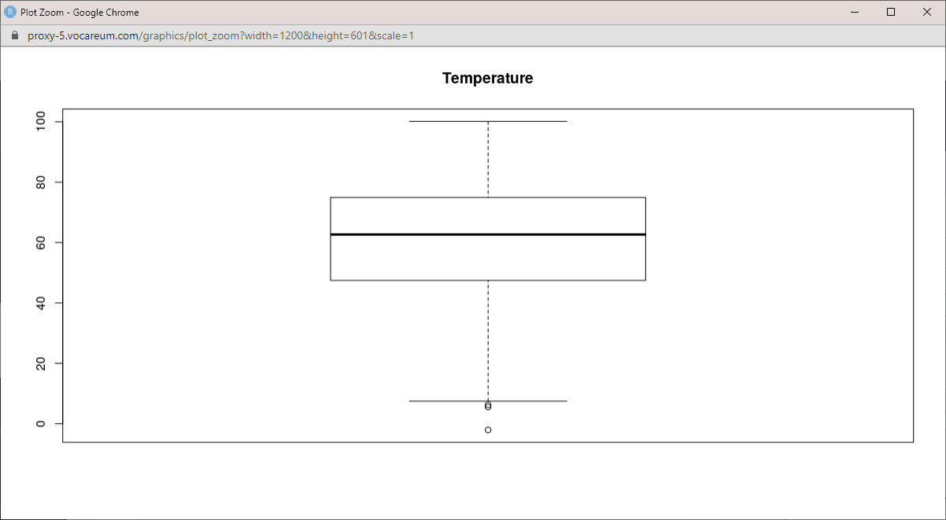
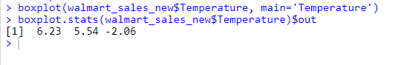

Step 2:
Drop the rows with outliers in the Temprature.

R Code:
walmart_sales_model = walmart_sales_new[walmart_sales_new$Temperature >= 7, ]

Step 3:
View the boxplot for Fuel Price

R Code:
boxplot(walmart_sales$Fuel_Price, main='Fuel_Price')
boxplot.stats(walmart_sales$Fuel_Price)$out

Screen Shot:
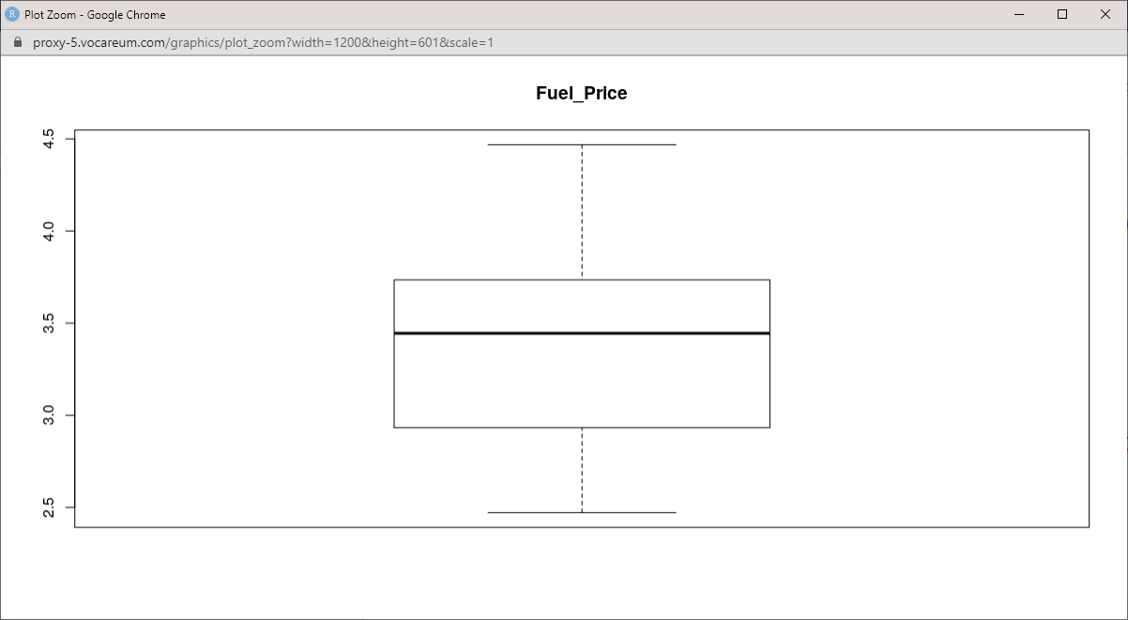
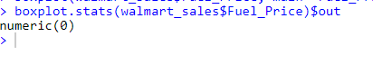

Step 4:
View the boxplot for CPI
R Code:
boxplot(walmart_sales_model$CPI, main='CPI')
boxplot.stats(walmart_sales$CPI)$out
Screen Shot:
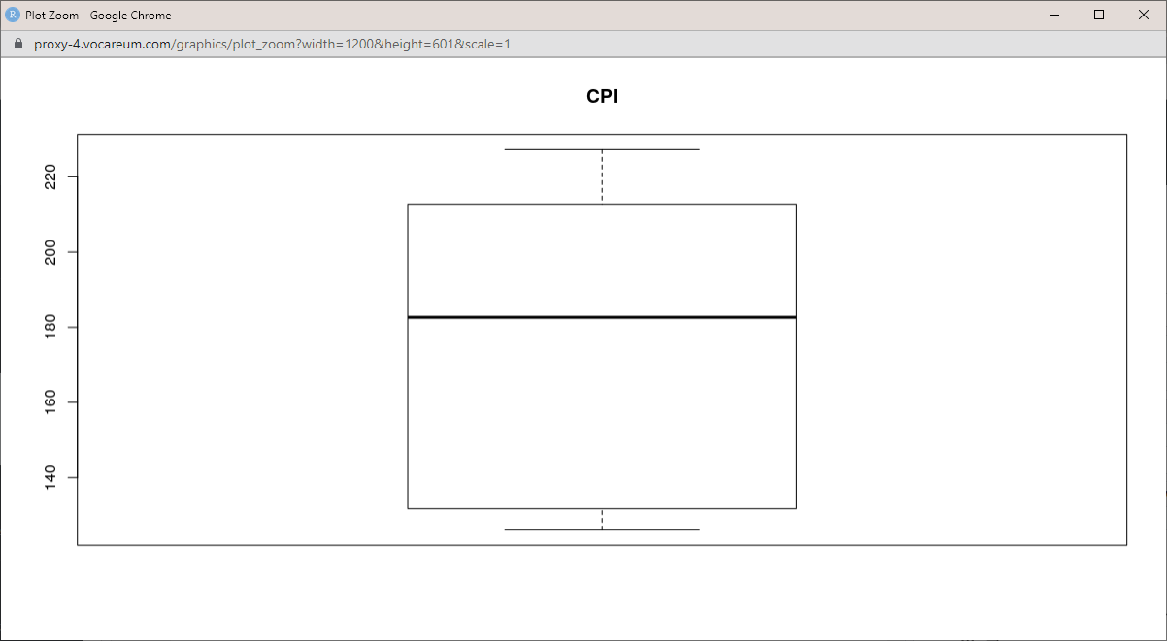
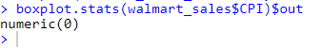

Step 5:
Box plot for Holiday Type
R Code:
# Boxplot for Holiday Type
boxplot(walmart_sales_model[, 3] ~ walmart_sales_model[, 12],
main = "Weekly Sales based on Holiday Type",
xlab ="Unemployment Index",
ylab ="Total Weekly Sales",
col="lightblue")
Screen Shot:
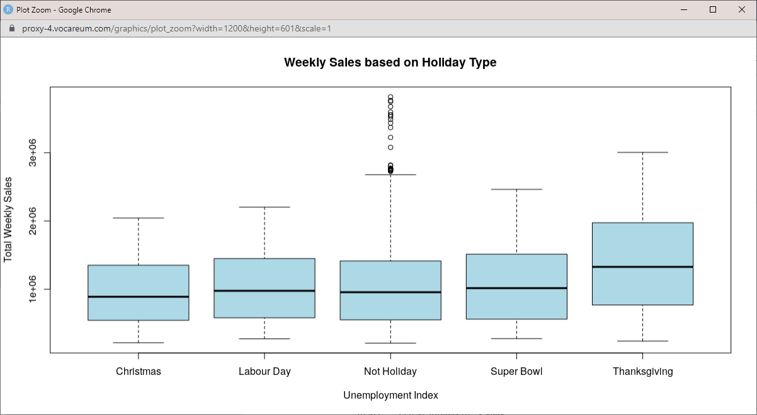

Step 6:
View the boxplot for Unemployment index
R Code:
boxplot(walmart_sales_new$Unemployment, main='Unemployment')
boxplot.stats(walmart_sales$Unemployment)$out

boxplot(walmart_sales[, 3] ~ walmart_sales[, 8],
main = "Weekly Sales based on Unemployment Index",
xlab ="Unemployment Index",
ylab ="Total Weekly Sales",
col="lightblue")

Screen Shot:
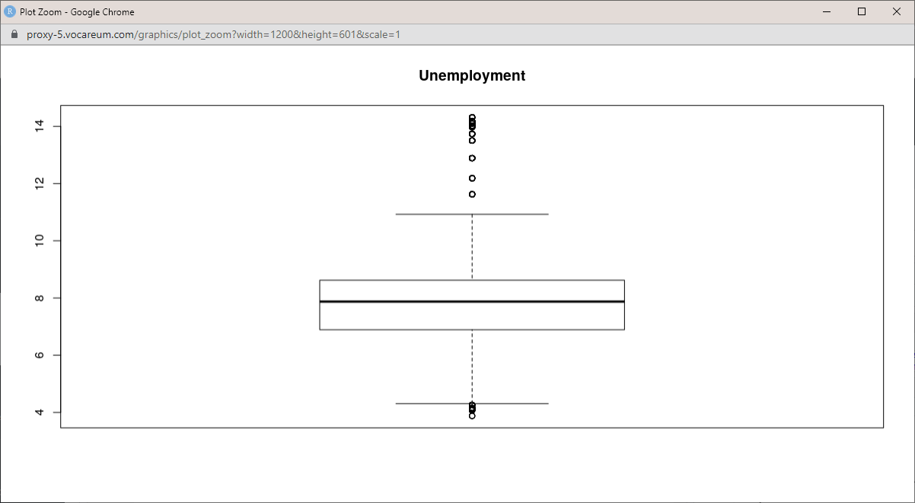
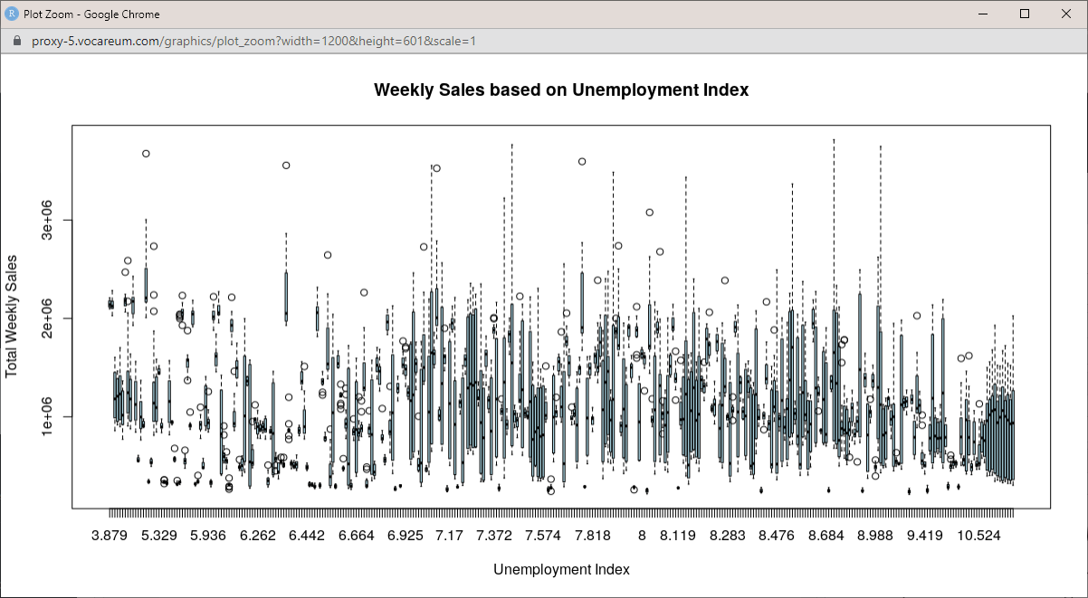
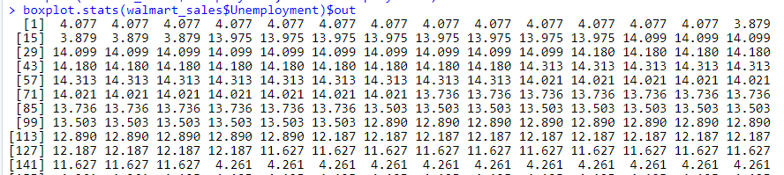

InSight:
There are outliers in the unemployment index data.

Step 7:
Box Plot for weekly sales
R Code:
# Boxplot for Weekly sales
boxplot(walmart_sales_model$Weekly_Sales, main='Weekly_Sales')
boxplot.stats(walmart_sales_model$Weekly_Sales)$out
Screen Shot:
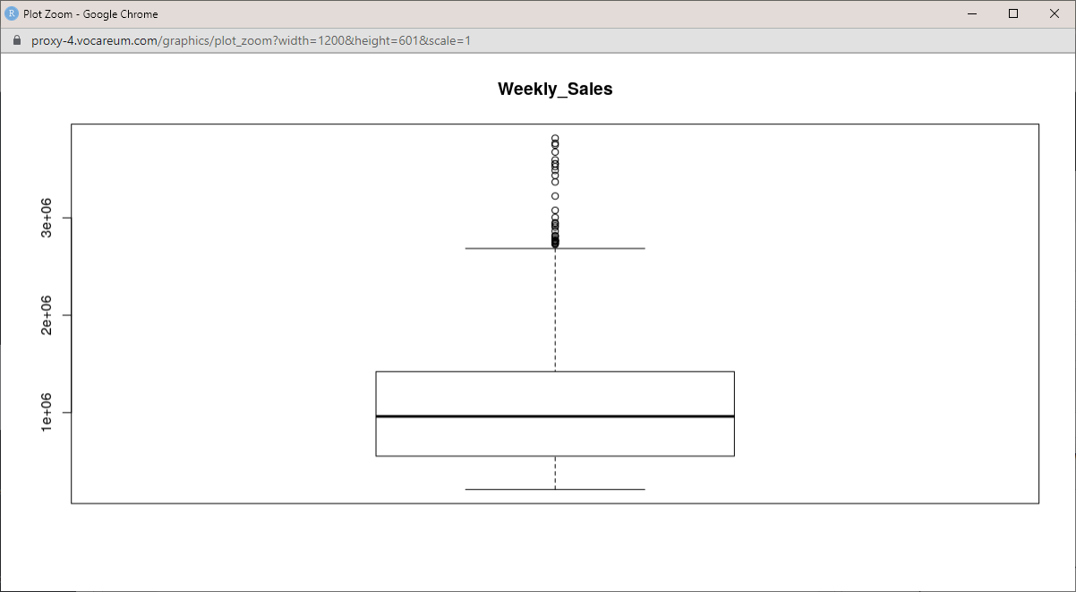

Step 8:
View the 1st and 99th percentile for the Unemployment index and Weekly sales.
R Code:
# View the 1st and 99th percentile values for Unemployemnt index
quantile(walmart_sales_model$Unemployment, 0.01)
quantile(walmart_sales_model$Unemployment, 0.99)

# View the 1st and 99th percentile values for weekly sales
quantile(walmart_sales_model$Weekly_Sales, 0.01)
quantile(walmart_sales_model$Weekly_Sales, 0.99)

Screen Shot:
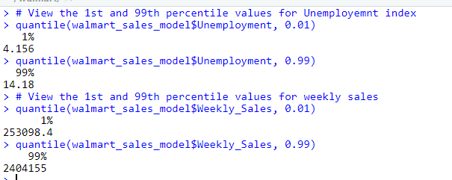

InSight:
Values less than the 1st percentile and above the 99th percentile are considered to be outliers.

Step 9:
Use IQR method to drop the outliers by setting the lower level - Q1-1.5*IQR and upper level - Q3+1.5*IQR for the weekly sales outlier.
R Code:
quantile(walmart_sales_model$Weekly_Sales)
IQR(walmart_sales_model$Weekly_Sales)
lowlevel <- (quantile(walmart_sales_model$Weekly_Sales)[2])-(1.5*IQR(walmart_sales_model$Weekly_Sales))
lowlevel

upperlevel <- (quantile(walmart_sales_model$Weekly_Sales)[4])+(1.5*IQR(walmart_sales_model$Weekly_Sales))
upperlevel

Screen Shot:
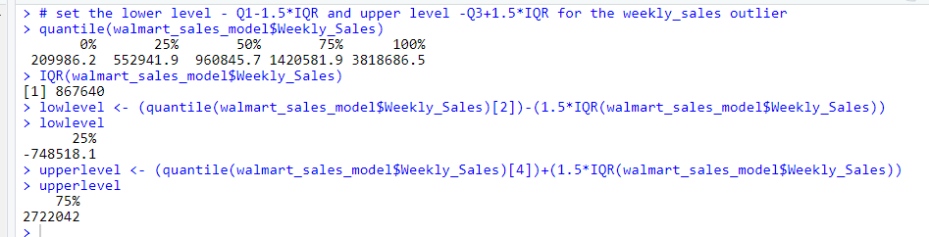

Step 10:
Drop the records with weekly sales based on the low and upper level. By creating a subset of the existing data frame.

R Code:
# Drop the weekly sales based on the low and upper level
walmart_sales_model$wesales_outlier <- ((walmart_sales_model$Weekly_Sales < lowlevel) | (walmart_sales_model$Weekly_Sales > upperlevel))
walmart_sales_model <- walmart_sales_model[walmart_sales_model$wesales_outlier == FALSE,]

# View the total number of records in the data frame
dim(walmart_sales_model)

Screen Shot:
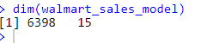

Step 11:
Drop the records which has outliers in the unemployment index.
Using the IQR method set the lower level and upper level to identify the outliers and dropped the records.

R Code:
# set the lower level - Q1-1.5*IQR and upper level -Q3+1.5*IQR for the Unemployment outlier
quantile(walmart_sales_model$Unemployment)
IQR(walmart_sales_model$Unemployment)
lowlevel1 <- (quantile(walmart_sales_model$Unemployment)[2])-(1.5*IQR(walmart_sales_model$Unemployment))
lowlevel1

upperlevel1 <- (quantile(walmart_sales_model$Unemployment)[4])+(1.5*IQR(walmart_sales_model$Unemployment))
upperlevel1

# Drop the weekly sales based on the low and upper level
walmart_sales_model$unemp_outlier <- ((walmart_sales_model$Unemployment < lowlevel1) | (walmart_sales_model$Unemployment > upperlevel1))
walmart_sales_model <- walmart_sales_model[walmart_sales_model$unemp_outlier == FALSE,]

# View the total number of records in the data frame
dim(walmart_sales_model)
# Records which are less than lower level and greater than upper level are considered
# as outliers.

Screen Shot:
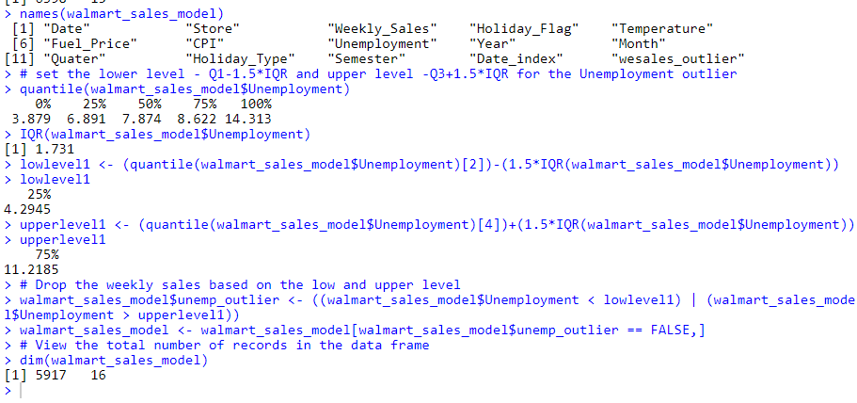

Insight:
All the outliers in the data frame are removed.

Step 10:
View the columns in the data frame and drop the unnecessary columns to build a model.
Following columns are dropped.
- Drop Date - as we have new date index field.
- Store – ID for each store not required for model building.
- Holiday-Flag – like holiday type column created.
- Year – created column to pick unique dates and 2012.
- Month- created column to view the month wise total sales.
- Quarter- created column to view the quarterly sales.
- Semester-created column to view the half yearly sales.
- Wesales_outlier – flag field created to identify the outliers
- Unemp_outlier – flag field created to identify the outliers.

R Code:
# View the names of the columns in the dataframe
names(walmart_sales_model)

# Dropping the columns which are not needed for model building
walmart_sales_model_dateindex = subset(walmart_sales_model, select = -c(Date,Store,Holiday_Flag,Year,Month,Semester,Quater,wesales_outlier,unemp_outlier))
View(walmart_sales_model_dateindex)
names(walmart_sales_model_dateindex)
Screen Shot:
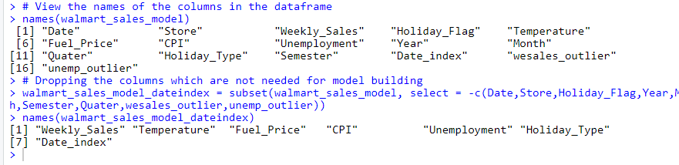
Creating Dummy Variables:

Step 11:
Create dummy variables for the Holiday type filed using the dummy method.
Combine the dummy variables to the data frame.
Drop the original holiday type column.
R Code:
# Create dummy variables for the Holiday type column.
Holiday_Type <- as.factor(walmart_sales_model_dateindex$Holiday_Type)
dummy_holiday <- data.frame(model.matrix(~Holiday_Type))[,-1]
View(dummy_holiday)

# Combine the dummy variables to the data frame
walmart_sales_model_dateindex <- cbind(walmart_sales_model_dateindex,dummy_holiday)
View(walmart_sales_model_dateindex)

#Drop the holiday type column
walmart_sales_model_dateindex = subset(walmart_sales_model_dateindex, select = -c(Holiday_Type) )
names(walmart_sales_model_dateindex)

Screen Shot:
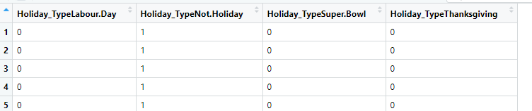
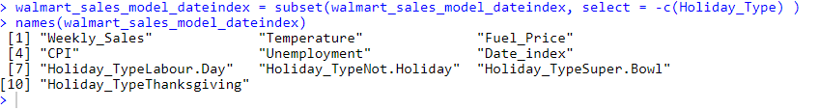

Step 10:
View the structure of the data frame
R Code:
# View the structure of the data frame
str(walmart_sales_model_dateindex)
Screen Shot:
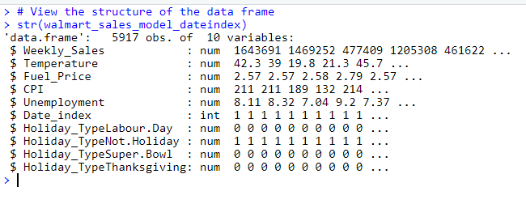

Step 11:
View the correlation plot using pairs.panels () function

R Code:
pairs.panels(walmart_sales_model_dateindex, gap=0, bg=c("red","yellow","blue")[walmart_sales_model_dateindex$Weekly_Sales], pch=21)

Screen Shot:
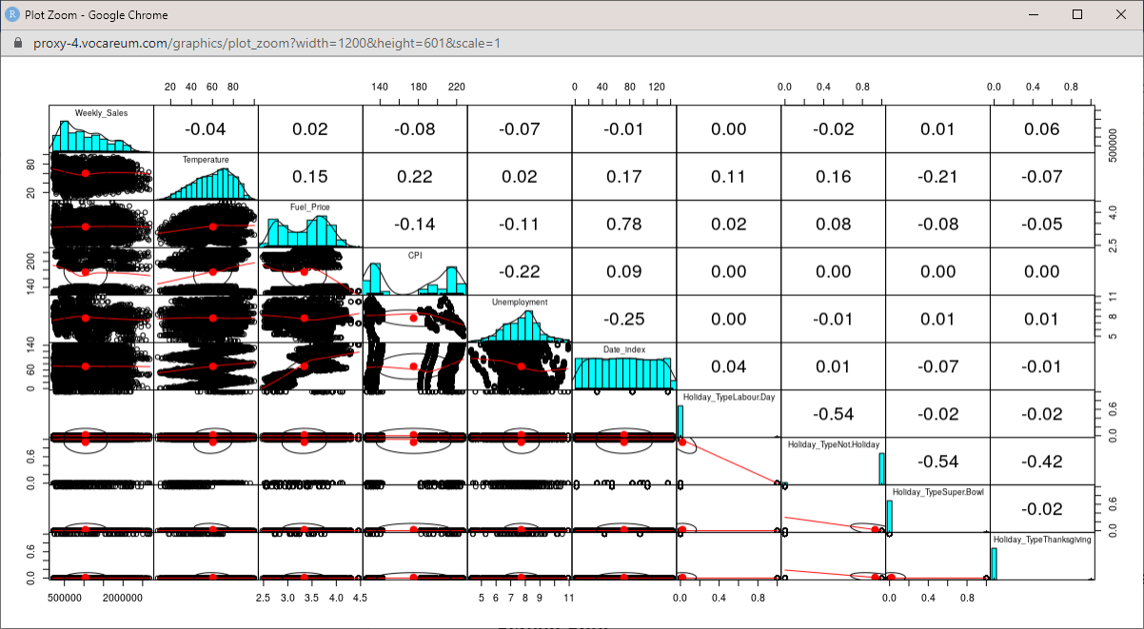

Step 12:
Checking correlation of weekly sales with other variables

R Code:
par(mfrow=c(1,1))

corr_index = cor(walmart_sales_model_dateindex[, 1:7])
View(corr_index)

Screen Shot:
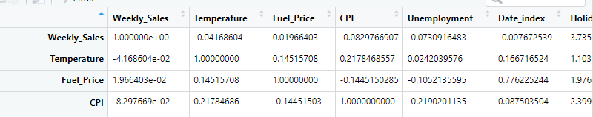

Step 13:
Visualize the correlation between the variables using the corrplot () function

R Code:
corrplot(corr_index, method = "color", outline = T, cl.pos = 'n', rect.col = "black", tl.col = "indianred4", addCoef.col = "black", number.digits = 2, number.cex = 0.60, tl.cex = 0.7, cl.cex = 1, col = colorRampPalette(c("blue","pink","red"))(100))
Screen Shot:
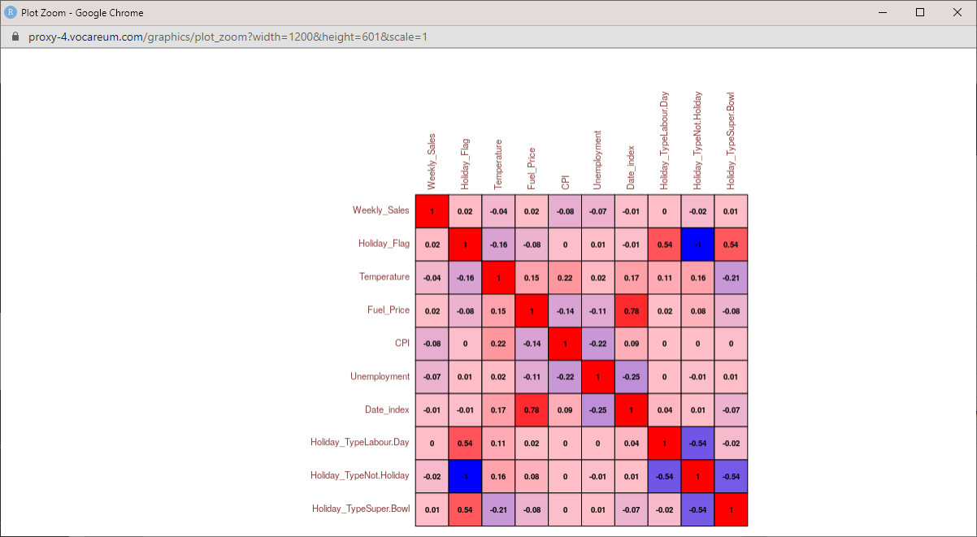

Step 14:
View the relationship between the fields with weekly sales
R Code:
# View the relationship between the fields with weekly sales
par(mfrow=c(3,3))

for(i in 2:10){
plot(walmart_sales_model_dateindex[,i],
walmart_sales_model_dateindex$Weekly_Sales,
main=names(walmart_sales_model_dateindex[i]),
ylab=names(walmart_sales_model_dateindex$Weekly_Sales),
xlab="", col='indianred4')
}

Screen Shot:
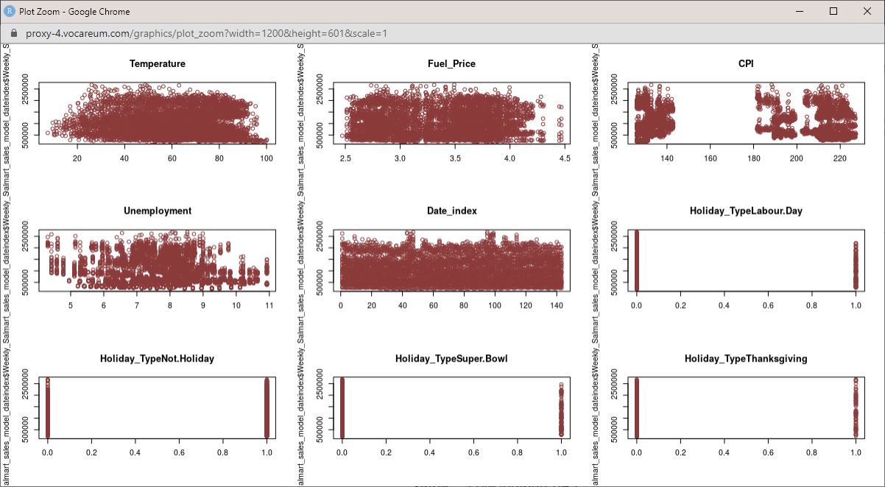

Data Split:

Step 1:
Splitting the data into training and testing data frame with 70%-30% split respectively.

R Code:
# Splitting dataset into training set and test set

set.seed(123) # Seed initializes the randomness

# Setting the splitratio using the sample.split () function
sample_index = sample.split(walmart_sales_model_dateindex, SplitRatio = 0.7)

# Subset the Training data where sample_index is set True
trainingSet_index = subset(walmart_sales_model_dateindex, sample_index == T)
dim(trainingSet_index)

# Subset the Testing data where sample_index is set False
testSet_index = subset(walmart_sales_model_dateindex, sample_index == F)
dim(testSet_index)

Screen Shot:
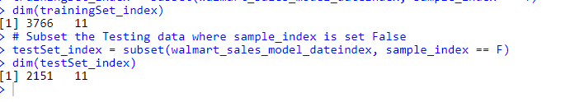

Multiple Linear Regression Model – 1: with Date Index

Step 2:
Create a Linear Regression Model using the lm () function using the training data.

R Code:
model_index = lm(formula = Weekly_Sales ~ . , data = trainingSet_index)
summary(model_index)

Screen Shot:
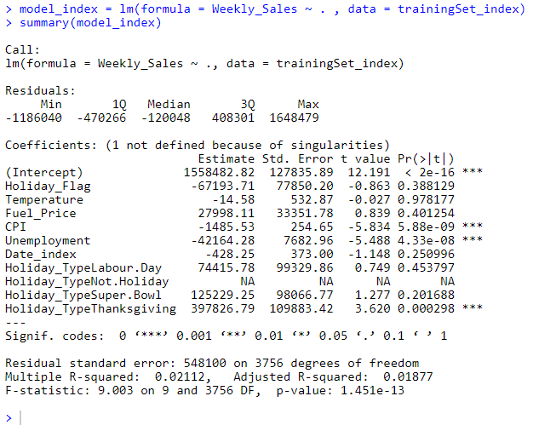

InSight:
Value of R square is low. Difference between R square and the Adjusted R square is less.
Temperature, CPI, Unemployment, and date index fields have negative residuals.
Holiday type fields and Fuel price have positive residuals. P value is also high for the Holiday type.

Step 3:
Predict the values in the test set data.

R Code:
# Predict the values for the test set data
y_pred_test_index = predict(model_index, newdata = testSet_index)
y_pred_test_index
length(y_pred_test_index)

# Visualizing the test set results
ggplot() +
geom_point(aes(x=testSet_index$Weekly_Sales,y=y_pred_test_index)) +
xlab('Actual Sales') +
ylab('Predicted Sales')+
ggtitle('Comparison of train data')

Screen Shot:
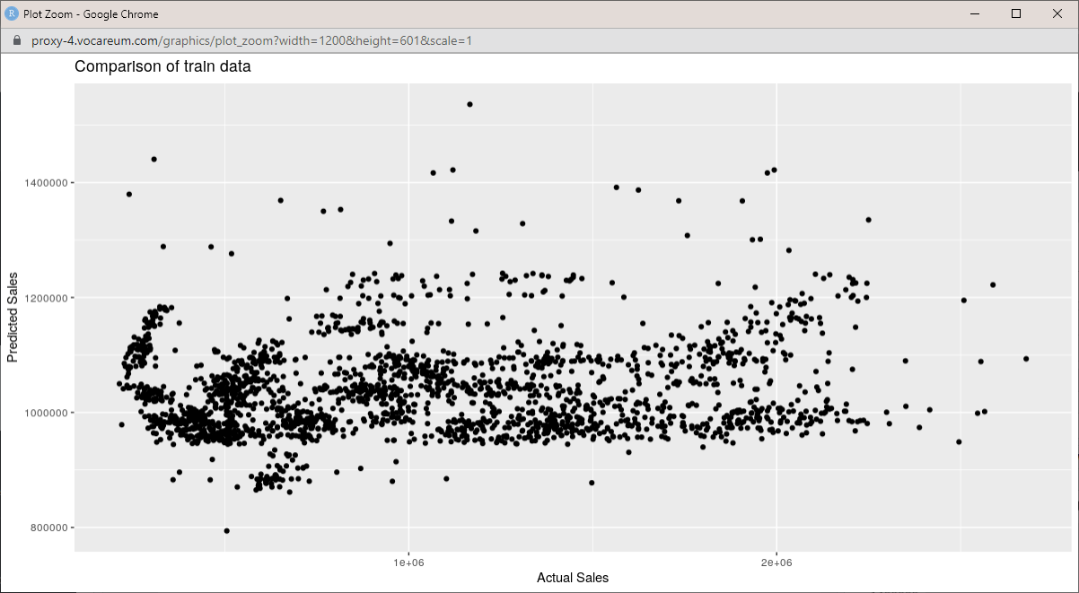

Step 4:
Parameters to validate the accuracy of the model and improvise.
Mean absolute Percentage error (MAPE) – Ratio of the absolute error with the actual value.
Root Mean square (RMSE) – square root of all the errors divided by the number of errors

R Code:
MAPE(y_pred_test_index,testSet_index$Weekly_Sales)
RMSE(y_pred_test_index,testSet_index$Weekly_Sales)

Screen Shot:
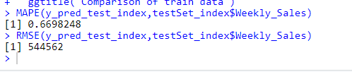

Multiple Linear Regression Model – 2: with Julian Days

Change dates into days by creating new variable.

Step 1:
View the data frame with the date index.

R Code:
# View the data frame with the dateindex
View (walmart_sales_model)

# View the column names of the dataframe with dateindex
names(walmart_sales_model)

Screen Shot:
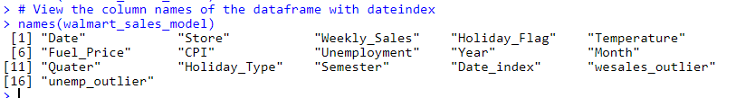

Step 2:
To create Julian date, View the unique Year in the data frame
R Code:
unique(walmart_sales_model$Year)

Screen Shot:
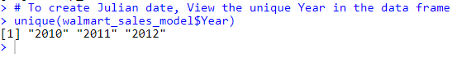

Step 4:
Create Julian date using the Julian () function for all the records, having the Unique dates as origin.

R Code:
for (i in 1:nrow(walmart_sales_model)){
if(walmart_sales_model$Year[i] == '2010'){
walmart_sales_model$Days[i] <- julian(walmart_sales_model$Date[i], origin = as.Date('2010-01-01'))
}else if (walmart_sales_model$Year[i] == '2011'){
walmart_sales_model$Days[i] <- julian(walmart_sales_model$Date[i], origin = as.Date('2011-01-01'))
}else{
walmart_sales_model$Days[i] <- julian(walmart_sales_model$Date[i], origin = as.Date('2012-01-01'))
}
}

View(walmart_sales_model)
Screen Shot:
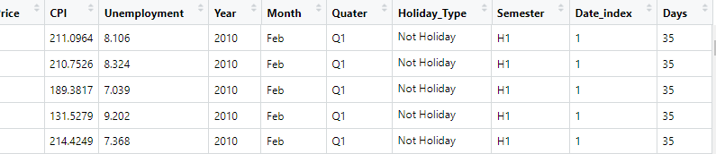

Step 5:
Creating dummy variables for the Holiday Type column
R Code:
# Create dummy variables for the Holiday type column.
Holiday_Type <- as.factor(walmart_sales_model$Holiday_Type)
dummy_holiday <- data.frame(model.matrix(~Holiday_Type))[,-1]
View(dummy_holiday)

Screen Shot:
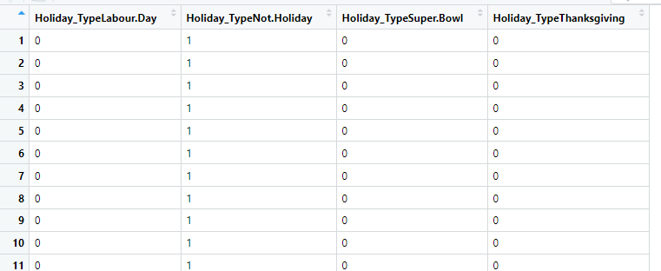

Step 6:
Create a new data frame by combining the date index data frame and the dummy variables
R Code:
# Combine the dummy variables to the data frame
walmart_sales_model_Juliandays <- cbind(walmart_sales_model,dummy_holiday)
View(walmart_sales_model_Juliandays)

Screen Shot:
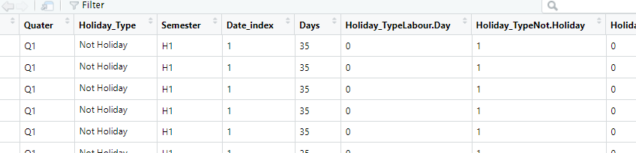

Step 7:
View the names of the new data frame and
Drop the columns which are not required for the model building.
R Code:
names(walmart_sales_model_Juliandays)
Screen Shot:
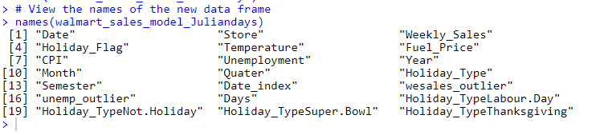
#Dropping the columns which are not needed for model building
walmart_sales_model_Juliandays = subset(walmart_sales_model_Juliandays, select = -c(Date,Store,Year,Month,Quater,Semester,Holiday_Type,unemp_outlier,wesales_outlier) )
View(walmart_sales_model_Juliandays)

names(walmart_sales_model_Juliandays)
Screen Shot:
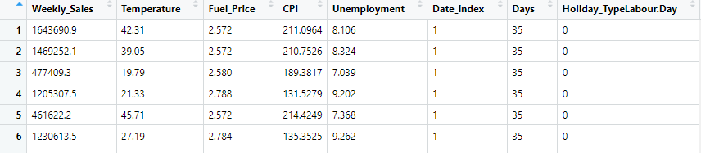

R Code:
names(walmart_sales_model_Juliandays)
Screen Shot:
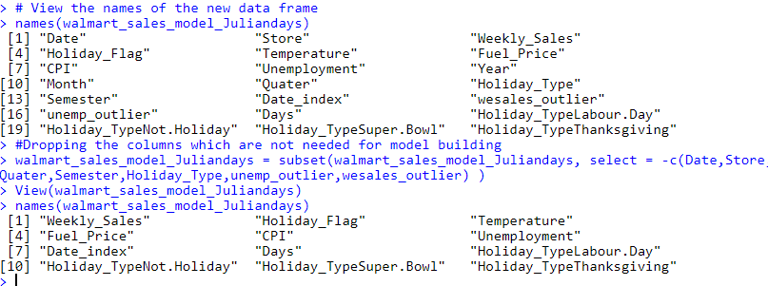

Step 8:
View the relationship between the variables with target variable
R Code:
par(mfrow=c(3,3))
for(i in 2:10){
plot(walmart_sales_model_Juliandays[,i],
walmart_sales_model_Juliandays$Weekly_Sales,
main=names(walmart_sales_model_Juliandays[i]),
ylab=names(walmart_sales_model_Juliandays$Weekly_Sales),
xlab="", col='indianred4')
}

Screen Shot:
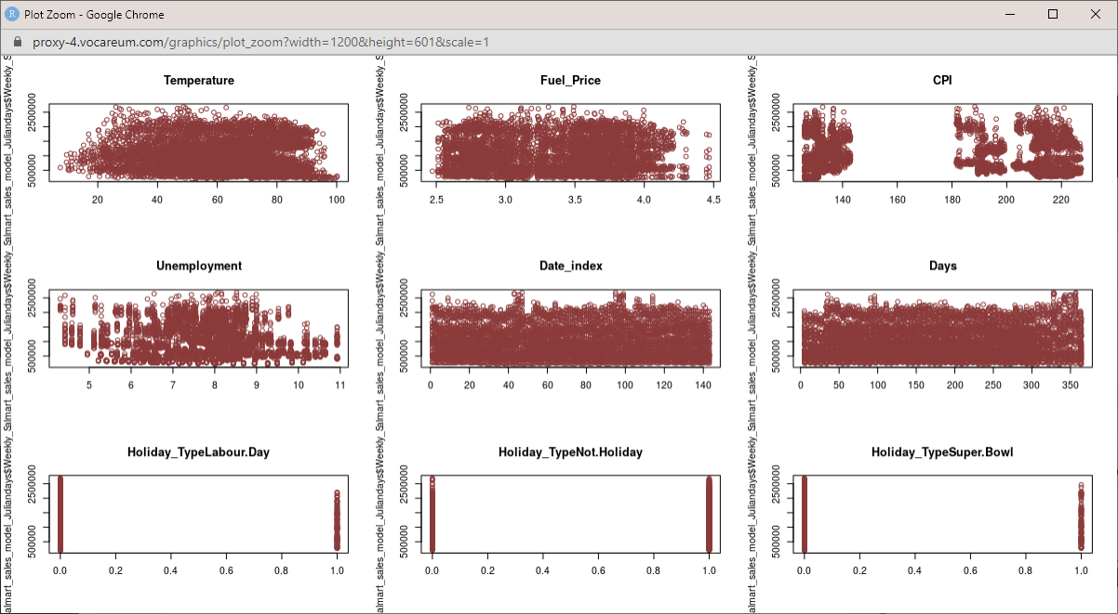

Step 9:
Checking correlation of weekly sales with other variables

R Code:
# Checking correlation of weekly sales with other variables
par(mfrow=c(1,1))
corr_days = cor(walmart_sales_model_Juliandays[, 1:11])
View(corr_days)

Screen Shot:
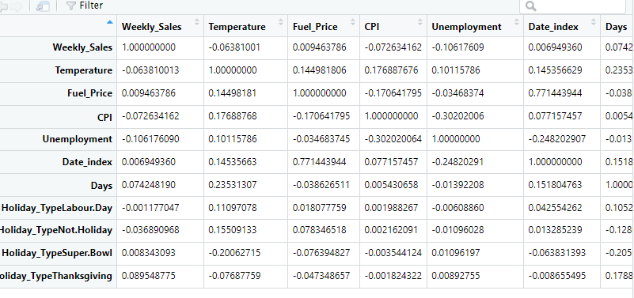

Visualize the correlation between the variables and weekly sales using the corrplot () function.

R Code:
corrplot(corr_days, method = "color", outline = T, cl.pos = 'n', rect.col = "black", tl.col = "indianred4", addCoef.col = "black", number.digits = 2, number.cex = 0.60, tl.cex = 0.7, cl.cex = 1, col = colorRampPalette(c("blue","pink","red"))(100))
Screen Shot:
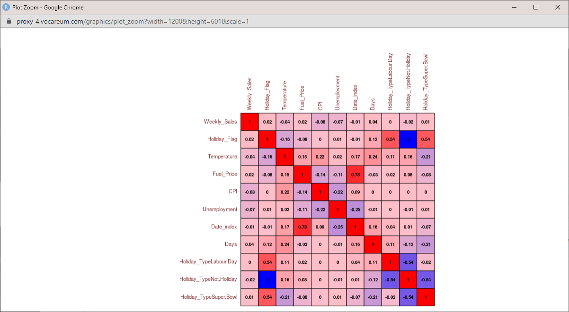

Step 10:
Splitting dataset into training set and test set into 70-30% respectively.

R Code:
set.seed(123) # Seed initializes the randomness

sample_days = sample.split(walmart_sales_model_Juliandays, SplitRatio = 0.7)

trainingSet_days = subset(walmart_sales_model_Juliandays, sample_days == T)
dim(trainingSet_days)

testSet_days = subset(walmart_sales_model_Juliandays, sample_days == F)
dim(testSet_days)
Screen Shot: 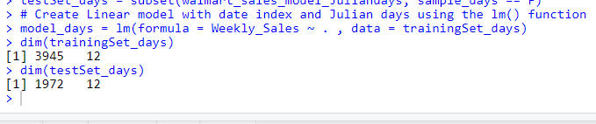

Step 11:
Create Linear model with date index and Julian days using the lm() function using the trainingSet data.

R Code:
model_days = lm(formula = Weekly_Sales ~ . , data = trainingSet_days)

summary(model_days)

Screen Shot:
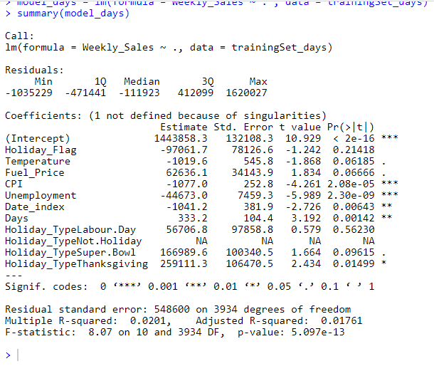
InSight:
Value of R square is low. Difference between R square and the Adjusted R square is less.
Temperature, CPI, Unemployment, and date index fields have negative residuals.
Holiday type fields and Fuel price have positive residuals. P value is also high for the Holiday type.
Step 14:
Predicting the values on the test data set using the model built on the training data

R Code:
y_pred_test_days = predict(model_days, newdata = testSet_days)

View (y_pred_test_days)
Screen Shot:
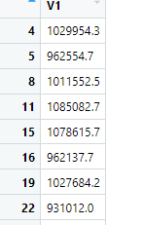

Step 15:
Visualize the predicted values for the testing data using the ggplot () function.
R Code:
# Visualize the predicted values on the test data
ggplot() +
geom_point(aes(x=testSet_days$Weekly_Sales,y=y_pred_test_days)) +
xlab('Actual Sales') +
ylab('Predicted Sales')+
ggtitle('comparison of test data')

Screen Shot:
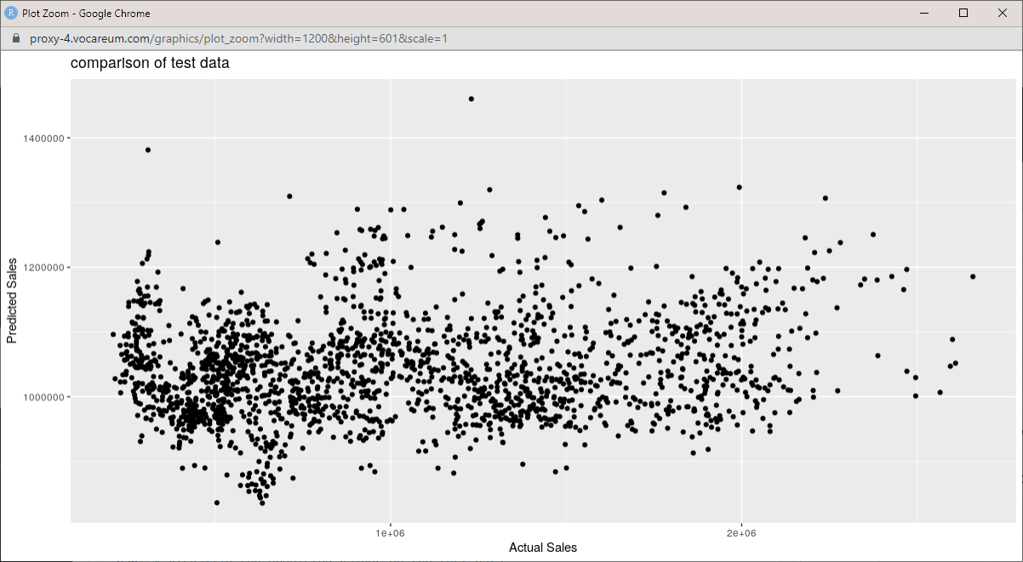

Step 16:
Parameters to validate the accuracy of the model and improvise.
R Code:
## Parameters to validate the accuracy of the model and improvise.

MAPE(y_pred_test_days,testSet_days$Weekly_Sales)

RMSE(y_pred_test_days,testSet_days$Weekly_Sales)

Screen Shot:
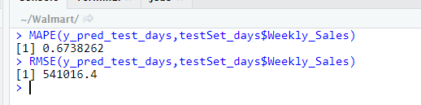

Better Model – Date Index + Julian Days is comparatively better than the model with Date index.

R squared of Model 2 is slightly higher than R squared of Model 1.

